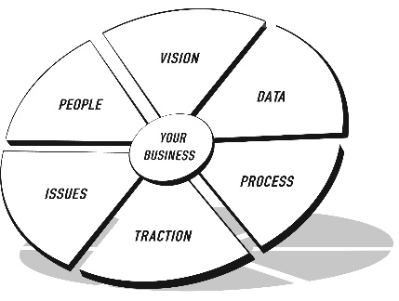
THE EOS MODEL™
THE VISION/TRACTION ORGANIZER™

ORGANIZATION NAME: M&J Client

VISION

CORE VALUES | - Core Value #1  - Core Value #2  - Core Value #3 | 3-YEAR PICTURE™
Future Date:
Revenue:
Profit:
Measurables:
What does it look like?

CORE FOCUS™ | Purpose/Cause/Passion:  Our Niche:
10-YEAR TARGET™
MARKETING  STRATEGY | Target Market/“The List”:  Three Uniques:  Proven Process:  Guarantee:
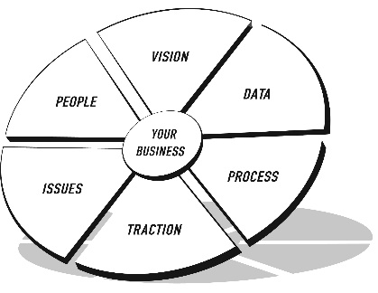
THE EOS MODEL™
THE VISION/TRACTION ORGANIZER™

ORGANIZATION NAME: M&J Client
TRACTION
1-YEAR PLAN | ROCKS | ISSUES LIST
Future Date:  Revenue:  Profit:  Measurables:  Goals for the Year:  1.  2.  3.  4.  5.  6.  7.  8.  With your cursor in the last row, press Tab to add another row. | Future Date:  Revenue:  Profit:  Measurables:  Rocks for the Quarter: Who  1.  2.  3.  4.  5.  6.  7.  8.  9.  10.  11.  With your cursor in the last row, press Tab to add another row. | 1.  2.  3.  4.  5.  6.  7.  8.  9.  10.  11.  12.  13.  14.  With your cursor in the last row, press Tab to add another row.

